Electric Vehicle Population Analysis and Predictive Modelling Using Machine Learning
Sushant Verma
Reg.no:12411245
School of Computing and Artificial Intelligence, Lovely Professional University, Punjab, India

Abstract—The growing adoption of electric vehicles (EVs) creates a need to understand vehicle-population patterns and evaluate data-driven methods for estimating electric range and classifying vehicle types. This paper presents an exploratory analysis of an EV population dataset containing 300,142 records and 16 fields. The workflow examines missing values, duplicate records, vehicle categories, electric-range outliers, and the correlation between model year and electric range. Five machine-learning approaches are included: simple linear regression, multiple linear regression, logistic regression, decision tree classification, and k-nearest neighbours (KNN). Regression models estimate electric range, while classification models distinguish battery electric vehicles (BEVs) from plug-in hybrid electric vehicles (PHEVs). The supplied code establishes a baseline, but final model metrics must be obtained by executing the corrected script; no performance values are fabricated in this draft.
Keywords— electric vehicles, exploratory data analysis, data preprocessing, linear regression, logistic regression, decision tree, KNN, predictive analytics

I. INTRODUCTION
The growing adoption of Electric Vehicles (EVs) has become an important part of the transition toward sustainable transportation. Electric vehicles provide an alternative to conventional fuel-powered vehicles and have gained attention due to their potential to reduce dependence on fossil fuels and lower environmental emissions. As the number of electric vehicles increases, analysing vehicle population data becomes useful for understanding adoption patterns, vehicle characteristics, and electric driving range.
The dataset used in this study is Electric Vehicle Population Data, which contains information about registered electric vehicles. It includes attributes such as model year, vehicle make, model, electric vehicle type, electric range, postal code, and geographical information. The dataset contains approximately 300,142 records and 16 columns. It includes two main categories of electric vehicles: Battery Electric Vehicles (BEVs), which operate entirely on electric power, and Plug-in Hybrid Electric Vehicles (PHEVs), which combine an electric motor with another power source. These attributes provide a basis for examining vehicle characteristics, comparing vehicle categories, and exploring patterns in electric range.
Before applying machine learning algorithms, the dataset is examined through exploratory data analysis (EDA). The preprocessing stage includes checking missing values, identifying duplicate records, examining unusual values, and analysing relationships between selected variables. Missing values are handled using suitable statistical methods, while outlier analysis helps identify observations that differ from the general distribution of the data.
Predictive analytics and machine learning provide techniques for identifying patterns and making predictions from historical data. In this study, five machine learning algorithms are considered: Simple Linear Regression, Multiple Linear Regression, Logistic Regression, Decision Tree Classifier, and K-Nearest Neighbors (KNN). The regression algorithms are used to estimate electric range, whereas the classification algorithms are used to distinguish between BEVs and PHEVs.
The main objective of this research is to analyse electric vehicle population data and compare different machine learning approaches for regression and classification tasks. The study demonstrates how data analysis and predictive modelling can be applied to understand electric vehicle characteristics and identify useful patterns within the dataset.
II. OBJECTIVES
The main objective of this study is to analyse electric vehicle population data and apply machine learning techniques to understand vehicle characteristics and predict electric vehicle attributes. The specific objectives are as follows:
- To analyse the dataset: Examine electric vehicle population data to understand vehicle types, model years, manufacturers, models, and electric driving range.
- To perform data preprocessing: Identify and handle missing values, check duplicate records, examine invalid values, and detect potential outliers to improve data quality.
- To perform exploratory data analysis: Investigate patterns and relationships among selected attributes using statistical analysis and visualisation techniques.
- To predict electric driving range: Apply Simple Linear Regression and Multiple Linear Regression to estimate electric range using selected input features.
- To classify electric vehicle types: Use Logistic Regression, Decision Tree Classifier, and K-Nearest Neighbors (KNN) to classify vehicles as Battery Electric Vehicles (BEVs) or Plug-in Hybrid Electric Vehicles (PHEVs).
- To compare machine learning algorithms: Evaluate the performance of the five selected algorithms using appropriate regression and classification metrics.
- To identify useful patterns: Interpret the analysis results to understand the relationships between vehicle model year, electric range, and electric vehicle categories.

III. DATASET DESCRIPTION
The dataset used in this study is the Electric Vehicle Population Data, which contains information about registered electric vehicles. It is used to analyse vehicle characteristics, electric driving range, manufacturer information, and the distribution of different electric vehicle types. The dataset contains approximately 300,142 records and 16 attributes, providing a basis for exploratory data analysis and machine learning.

A. Dataset Attributes
The dataset contains information related to vehicle identification, technical specifications, and geographical location. Important attributes include:
- Model Year: The manufacturing model year of the vehicle.
- Make: The vehicle manufacturer, such as Tesla, Nissan, or Chevrolet.
- Model: The specific model of the electric vehicle.
- Electric Vehicle Type: Identifies whether the vehicle is a Battery Electric Vehicle (BEV) or a Plug-in Hybrid Electric Vehicle (PHEV).
- Electric Range: The recorded electric driving range of the vehicle.
- Postal Code: The postal code associated with the vehicle's registered location.
- County and City: Geographical information about the vehicle's registration.
- Electric Utility: Information about the electric utility associated with the registered location.
- Legislative District: The legislative district associated with the vehicle's location.
Other attributes provide additional information about vehicle registration and geographical identification.
Link: https://catalog.data.gov/dataset/electric-vehicle-population-data?from_hint=eyJxIjoiRWxlY3RyaWMgVmVoaWNsZSBQb3B1bGF0aW9uIERhdGEifQ%3D%3D
IV. PREPROCESSING AND EXPLORATORY ANALYSIS
The preprocessing stage involved inspecting the dataset structure, data types, descriptive statistics, missing-value counts, and missing-value percentages. Missing numerical values were imputed using the median, while missing categorical values were replaced with the mode. Duplicate records were checked and removed if present. Additional validation checks were performed to identify negative model years and negative electric range values. Records with zero electric range were counted separately.
The initial analysis identified 197,120 records with zero electric range. These values were not automatically treated as missing because zero may indicate that electric range is not applicable or is not recorded for certain vehicles. For regression analysis, only records with positive electric range were retained, resulting in 103,022 records. This filtering decision was made specifically for the electric-range prediction task.
Outlier detection was performed using the Interquartile Range (IQR) method and a box plot. The first quartile (Q1), third quartile (Q3), and IQR were calculated to determine the lower and upper limits. The observed limits were −48 miles and 80 miles, respectively. A total of 42,520 records were flagged as potential outliers. These observations were retained for investigation rather than automatically removed because higher electric-range values may represent valid vehicle characteristics.
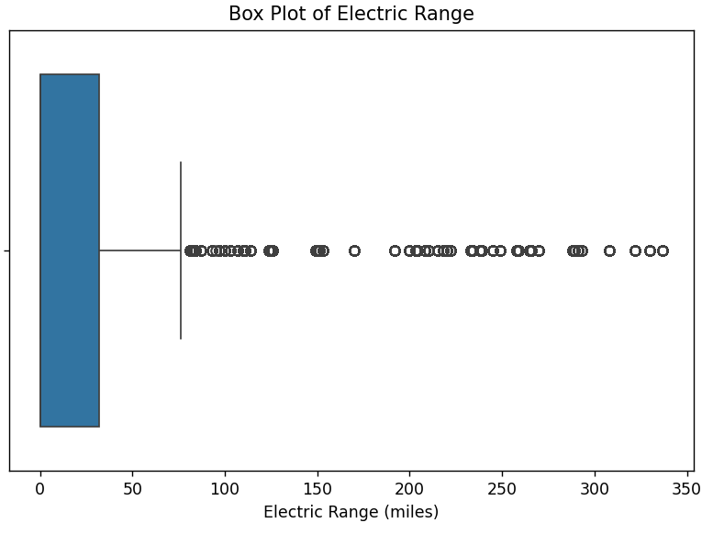
Fig.1: Box plot of electric range showing the distribution and potential outliers in the dataset.
Correlation analysis was conducted to examine the relationship between Model Year and Electric Range. The observed correlation coefficient was approximately −0.55 in the initial analysis, indicating a negative linear association in the records used for that calculation. This result does not establish a causal relationship and should be interpreted according to the dataset subset and preprocessing steps used.
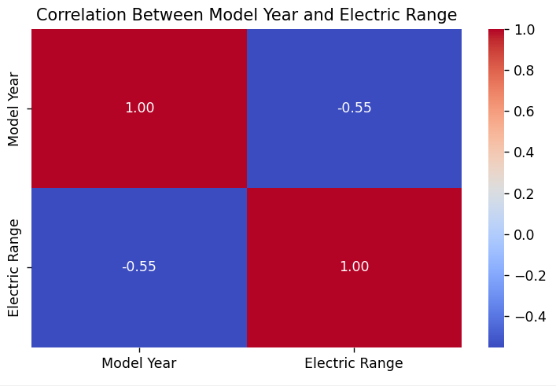
Fig.2: Correlation heatmap between Model Year and Electric Range.
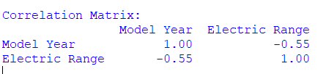
Overall, preprocessing and exploratory analysis helped assess data quality, understand the distribution of electric range, and prepare suitable subsets for regression and classification. The findings also highlighted the importance of distinguishing genuine vehicle characteristics from missing, invalid, or unusual observations before applying machine learning algorithms.
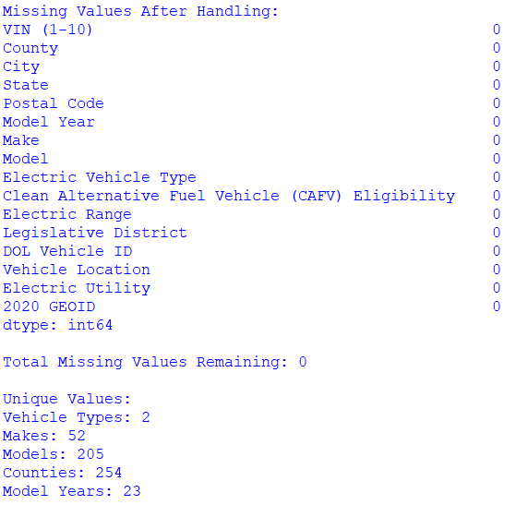
Fig.3: Missing values after preprocessing and unique values across selected dataset attributes.
V. MACHINE-LEARNING METHODS
Five machine learning algorithms were selected to perform regression and classification tasks on the Electric Vehicle Population dataset. Simple Linear Regression and Multiple Linear Regression were used to predict electric range, while Logistic Regression, Decision Tree Classifier, and K-Nearest Neighbors (KNN) were used to classify electric vehicles as Battery Electric Vehicles (BEVs) or Plug-in Hybrid Electric Vehicles (PHEVs).
A. Simple Linear Regression
Simple Linear Regression (SLR) is a supervised learning algorithm that examines the linear relationship between one independent variable and a continuous dependent variable. In this study, Model Year was used as the input feature, and Electric Range was the target variable. The model estimates electric range using the following equation:
ŷ = β₀ + β₁x₁
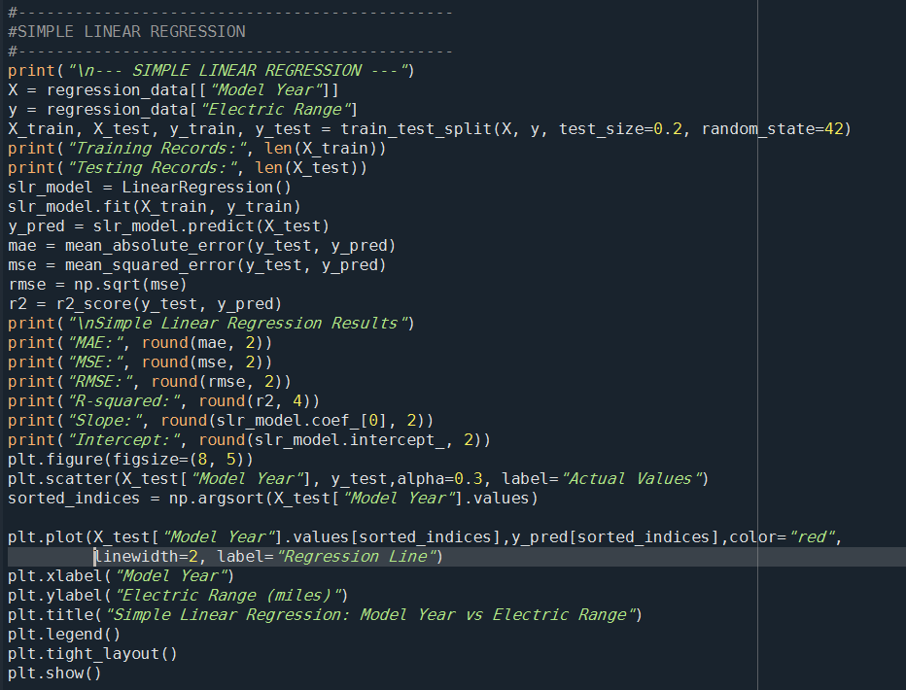
Fig.4: Python implementation of Simple Linear Regression for electric range prediction.
where (x) represents Model Year, ŷ represents the predicted electric range, β₀ is the intercept, and β₁ is the regression coefficient. The model was applied to investigate whether Model Year can help estimate the electric range of a vehicle.
B. Multiple Linear Regression
Multiple Linear Regression (MLR) extends simple linear regression by using two or more independent variables to predict a continuous target. In this project, Model Year and Postal Code were used as input features, while Electric Range was the target variable. The model can be represented as:
ŷ = β₀ + β₁x₁ + β₂x₂
where x₁ represents Model Year and x₂ represents Postal Code. The model was used to examine the combined predictive contribution of these features to electric range. The usefulness of Postal Code as a predictor requires evaluation using test-set results.
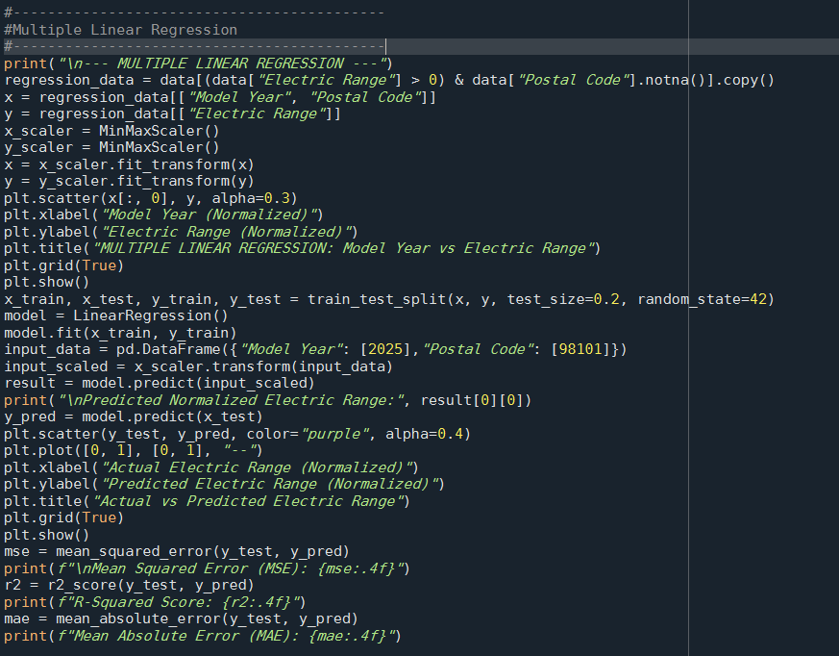
Fig.5: Python implementation of Multiple Linear Regression for electric range prediction.
C. Logistic Regression
Logistic Regression is a supervised classification algorithm that estimates the probability of an observation belonging to a particular class. In this study, it was used to classify vehicles into BEV and PHEV categories. Model Year was used as the input feature, and Electric Vehicle Type was the target variable. The target categories were encoded numerically for model training. Logistic Regression estimates class probabilities and assigns a predicted category based on the classification threshold. Its performance was evaluated as a binary classification task.
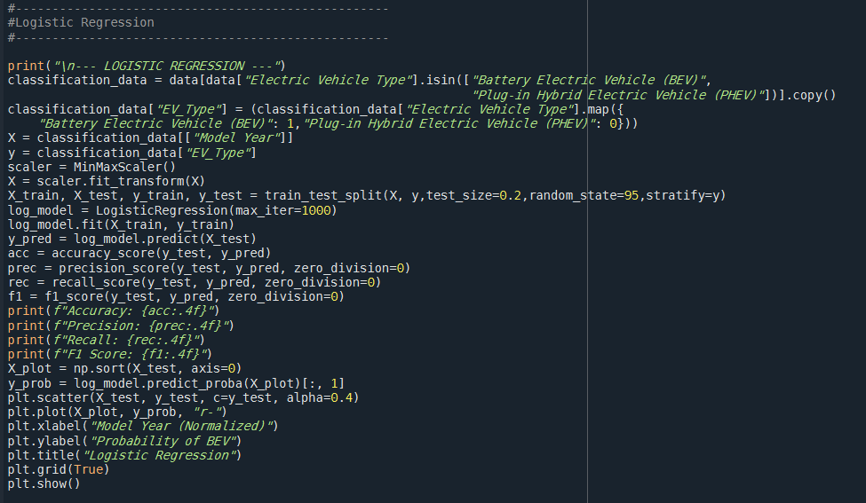
Fig.6: Python implementation of Logistic Regression for electric vehicle classification.
D. Decision Tree Classifier
The Decision Tree Classifier is a supervised learning algorithm that makes predictions through a sequence of feature-based decision rules. Each internal node represents a decision, each branch represents an outcome, and each leaf node represents a predicted class. In this project, Model Year was used to classify vehicles as BEVs or PHEVs. The model provides a straightforward way to represent classification rules and can capture nonlinear decision boundaries. However, its predictive performance depends on the information available in the input features and the model's configuration.
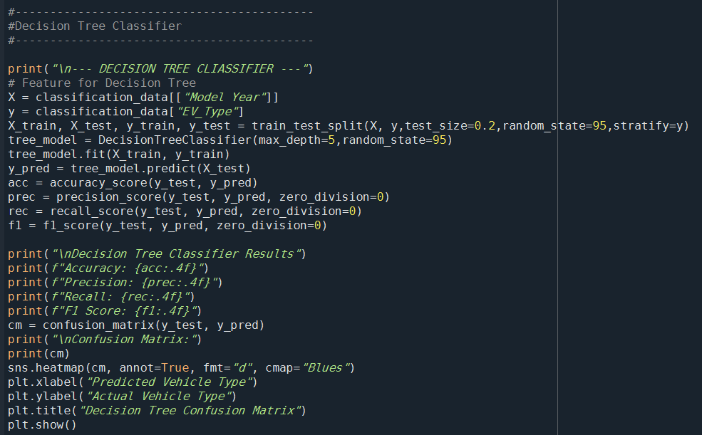
Fig.7: Python implementation of the Decision Tree Classifier for electric vehicle classification.
E. K-Nearest Neighbors (KNN)
K-Nearest Neighbours is a supervised learning algorithm that predicts the class of a new observation by examining the classes of its nearest training observations. In this project, KNN was applied to classify electric vehicles as BEVs or PHEVs using Model Year as the input feature. The algorithm identifies the nearest observations according to a distance measure and assigns the class based on the neighboring observations. Since KNN relies on distances between data points, feature scaling can be important when multiple numerical features are used.
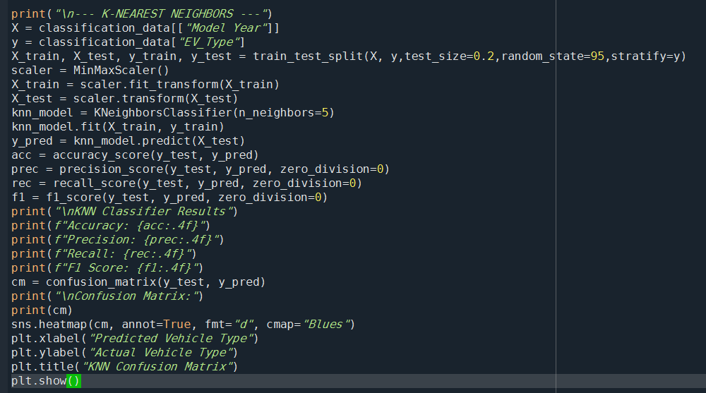
Fig.8: Python implementation of the K-Nearest Neighbors classifier for electric vehicle classification.
F. Model Evaluation
The five algorithms were evaluated according to their respective tasks. Regression models should be assessed using Mean Absolute Error (MAE), Root Mean Squared Error (RMSE), and the coefficient of determination (R²). Classification models should be assessed using accuracy, precision, recall, and F1-score, supported by a confusion matrix where appropriate. These metrics provide a basis for comparing model performance on unseen test data.
VI. EXPERIMENTAL DESIGN AND EVALUATION
The experimental design was established to evaluate five machine learning algorithms on the Electric Vehicle Population dataset. The experiments were divided into regression and classification tasks. Simple Linear Regression (SLR) and Multiple Linear Regression (MLR) were used to predict Electric Range, while Logistic Regression, Decision Tree Classifier, and K-Nearest Neighbors (KNN) were used to classify vehicles as Battery Electric Vehicles (BEVs) or Plug-in Hybrid Electric Vehicles (PHEVs).
A. Experimental Setup
The dataset initially contained approximately 300,142 records and 16 attributes. After preprocessing, records with positive Electric Range were selected for regression, resulting in 103,022 records in the observed run. For regression, SLR used Model Year as the input feature, whereas MLR used Model Year and Postal Code. For classification, the three selected algorithms used Model Year as the input feature and Electric Vehicle Type as the target variable.
The data was prepared for model training and evaluation using a training and testing approach. The training set was used to fit the models, while the testing set was used to evaluate their performance on unseen observations. Any scaling or transformation required by a model should be fitted on the training set and then applied to the testing set to avoid data leakage.
B. Regression Evaluation
The regression models were evaluated using Mean Absolute Error (MAE), Root Mean Squared Error (RMSE), and the coefficient of determination (R²). MAE measures the average absolute difference between actual and predicted electric-range values. RMSE gives greater weight to larger prediction errors, while (R²) indicates how well the model explains variation in the target variable.
Lower MAE and RMSE values indicate smaller prediction errors, while a higher (R²) generally indicates a better fit to the evaluation data. These metrics were selected to compare the predictive performance of SLR and MLR.

C. Classification Evaluation
Logistic Regression, Decision Tree Classifier, and KNN were evaluated as binary classification models. Accuracy measures the proportion of correctly classified observations. Precision measures the proportion of predicted positive cases that are correct, while recall measures the proportion of actual positive cases correctly identified. The F1-score combines precision and recall into a single measure.
A confusion matrix can also be used to examine correct and incorrect predictions for both vehicle categories. Since the dataset contains more BEVs than PHEVs, accuracy should be interpreted alongside precision, recall, and F1-score.
D. Comparative Evaluation
The five algorithms were considered according to their respective objectives. The regression models were compared using MAE, RMSE, and (R²), while the classification models were compared using accuracy, precision, recall, and F1-score. The final comparison should be based on the actual test-set results produced by the Python implementation.
This evaluation framework provides a consistent basis for identifying the relative strengths and limitations of the selected machine learning approaches for electric vehicle population analysis.
VII. RESULTS AND DISCUSSION
A. Simple Linear Regression
Problem addressed: Can the Model Year of an electric vehicle help predict its Electric Range?
Simple Linear Regression was used to study the relationship between Model Year and Electric Range. It takes Model Year as the input and predicts the expected electric driving range in miles. The model achieved an MAE of 79.95 miles, an RMSE of 92.85 miles, and an (R²) score of 0.0808. The low (R²) indicates that Model Year alone has limited ability to explain variations in Electric Range.
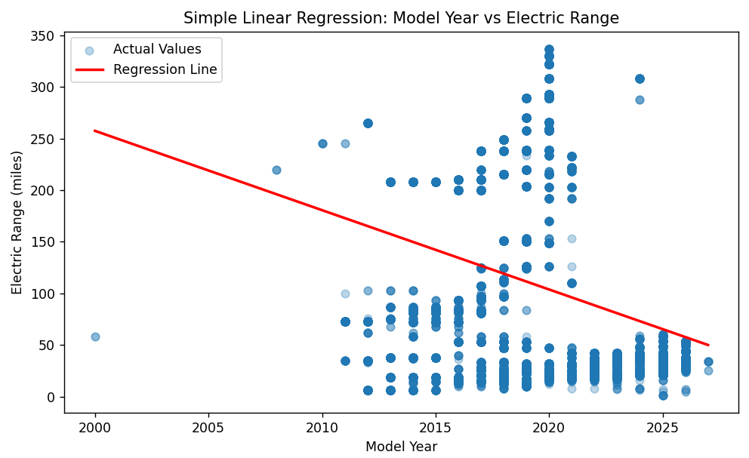
Fig.9: Simple Linear Regression showing the relationship between Model Year and Electric Range.
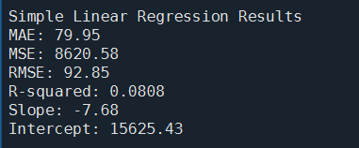
B. Multiple Linear Regression
Problem addressed: Can Model Year and Postal Code together improve Electric Range prediction?
Multiple Linear Regression uses two input features, Model Year and Postal Code, to estimate Electric Range. Its purpose is to determine whether combining these variables improves prediction compared with using Model Year alone. The model achieved an (R²) score of 0.0807 on the normalized target. This result indicates that the selected features explain only a small proportion of the variation in Electric Range.
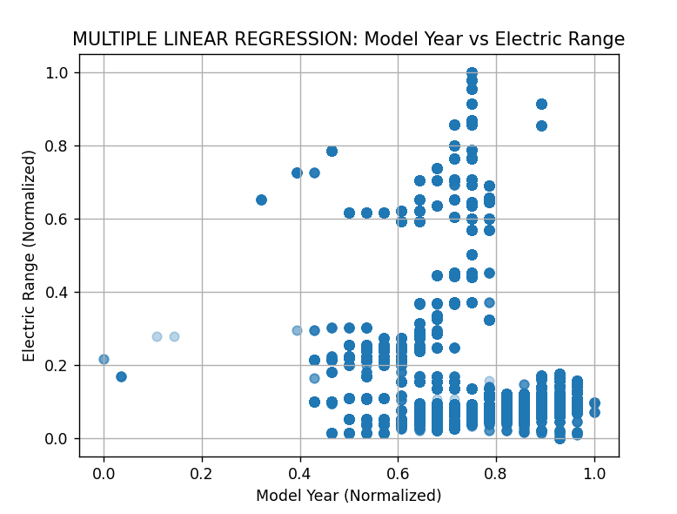
Fig.10: Multiple Linear Regression plot showing normalized Model Year and Electric Range.
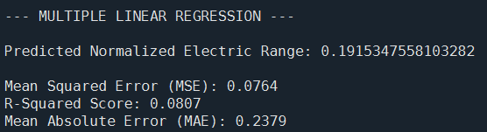
C. Logistic Regression
Problem addressed: Can an electric vehicle be classified as a BEV or PHEV based on its Model Year?
Logistic Regression estimates the probability that a vehicle belongs to a particular category. In this project, Model Year was used to classify vehicles as Battery Electric Vehicles (BEVs) or Plug-in Hybrid Electric Vehicles (PHEVs). The model achieved 80.56% accuracy and an F1-score of 89.24%. However, its high recall and the class imbalance suggest that further class-specific evaluation is needed to understand its ability to identify PHEVs correctly.
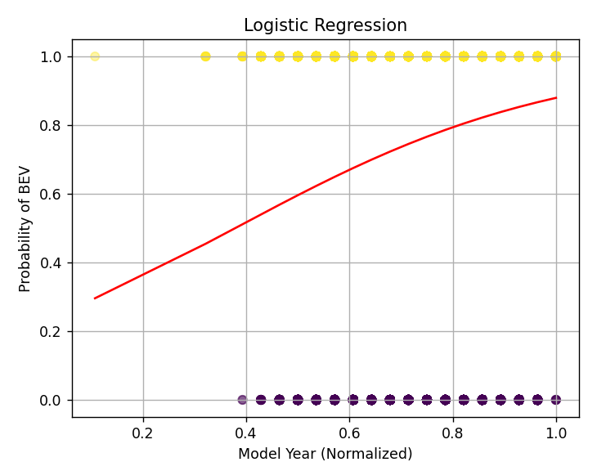
Fig.11: Logistic Regression plot showing the predicted probability of a vehicle being a BEV against normalized Model Year.
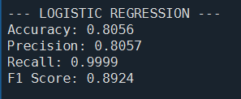
D. Decision Tree Classifier
Problem addressed: Can decision rules based on Model Year distinguish BEVs from PHEVs?
The Decision Tree Classifier learns decision rules from the training data to predict the vehicle category. It achieved 80.58% accuracy and an F1-score of 89.19%, giving it the highest accuracy among the three classification models in this experiment. However, the confusion matrix indicates that many PHEVs were incorrectly classified as BEVs. This suggests that Model Year alone does not provide enough information to reliably distinguish the two categories.
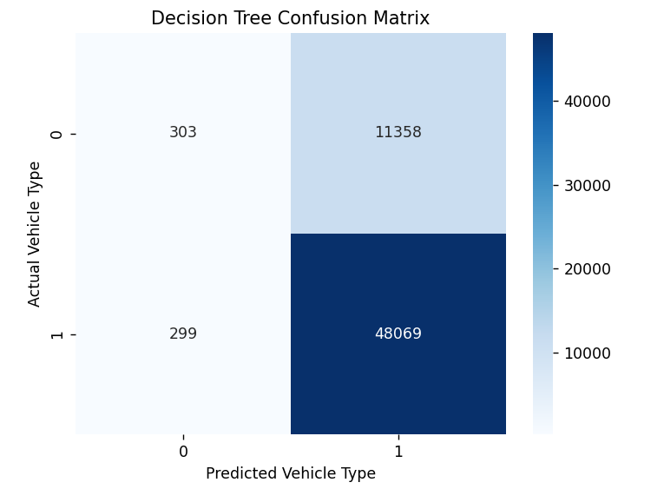
Fig.12: Confusion matrix of the Decision Tree Classifier for electric vehicle classification.
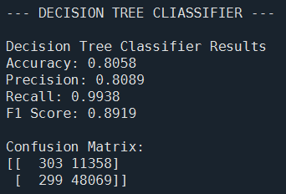
E. K-Nearest Neighbors (KNN)
Problem addressed: Can the vehicle category be predicted by comparing its Model Year with those of similar vehicles?
KNN classifies a vehicle by examining the categories of its nearest training observations. In this project, (K=5) was used, meaning the five nearest observations were considered when making a prediction. The model achieved 78.83% accuracy and an F1-score of 87.69%. Although its accuracy was lower than that of the other classifiers, it achieved the highest precision at 82.49%.

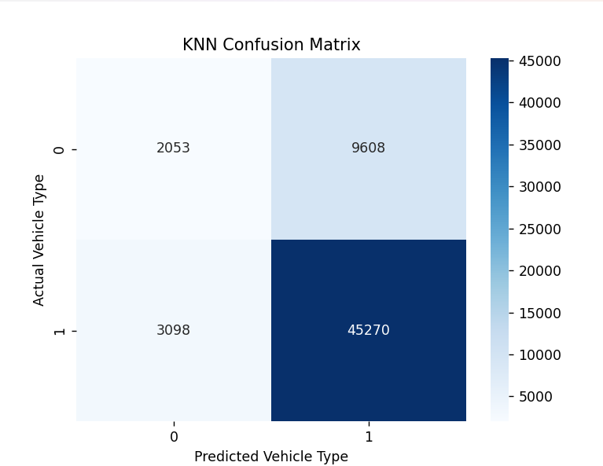
Fig.13: Confusion matrix of the K-Nearest Neighbors (KNN) classifier for electric vehicle classification.
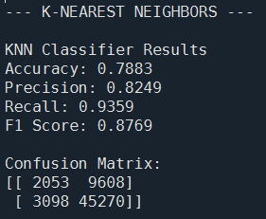
F. Overall Discussion
The regression algorithms investigated whether the selected features could predict Electric Range, while the classification algorithms attempted to distinguish BEVs from PHEVs. Both regression models produced low (R²) scores, indicating limited predictive power. Among the classifiers, the Decision Tree achieved the highest accuracy, whereas Logistic Regression achieved the highest F1-score.
Overall, the results indicate that additional informative features, such as vehicle make and model, may be needed to improve predictions. These features should be selected carefully and evaluated without introducing data leakage.
IX. CONCLUSION
This study analysed the Electric Vehicle Population dataset containing approximately 300,142 records and applied five machine learning algorithms for regression and classification tasks. Data pre-processing and exploratory analysis were performed to handle missing values, examine potential outliers, and investigate relationships between selected attributes.
Simple Linear Regression and Multiple Linear Regression were used to predict Electric Range, achieving ( R²) scores of 0.0808 and 0.0807, respectively. These results indicate limited predictive performance with the selected features. For vehicle classification, the Decision Tree Classifier achieved the highest accuracy of 80.58%, while Logistic Regression obtained the highest F1-score of 89.24%. K-Nearest Neighbors achieved an accuracy of 78.83%.
Overall, the results demonstrate the application of machine learning to electric vehicle data while highlighting the limitations of using Model Year and Postal Code alone. Future work could investigate additional vehicle attributes, improve feature selection, and evaluate further algorithms to enhance prediction accuracy and classification performance.
Table.1: Model Performance Comparison (Enter Actual Run Results)
Model | Task
Simple Linear Regression | Regression
Multiple Linear Regression | Regression
Logistic Regression | Classification
Decision Tree | Classification
KNN (k=5) | Classification
X. REFERENCES
[1] Dataset Link: DATA_SET_LINK
[2] LinkedIn: LINKEDIN_LINK
[3] GitHub: GITHUB_LINK
[4]

